How to make a pin wheel

Materials you will need 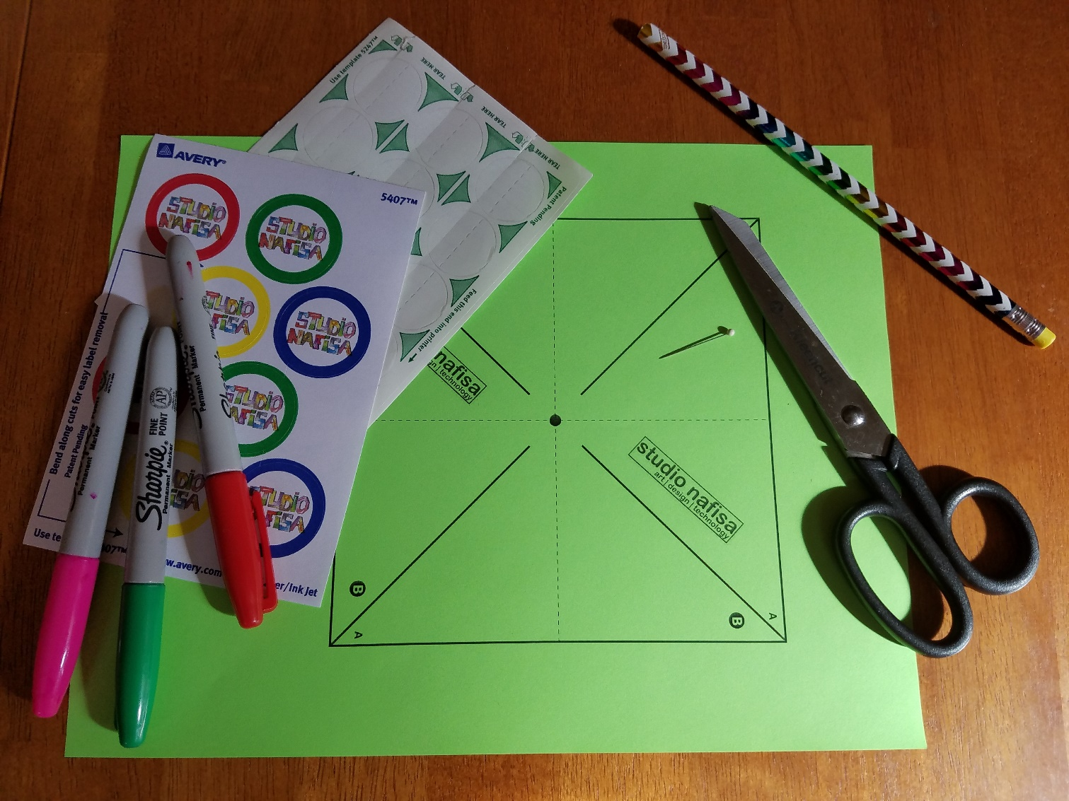

Pencil
Printed template
Markers to draw
Pin (1 1/8”)
2 Round stickers or clear tabs (1” diameter)
Scissors

Instructions for making a pinwheel

- Print the pin wheel template on a regular 8.5”X11” printer paper. For best results use a 25lb paper (this paper is a little thicker than the printer paper).

- Cut on outside solid lines to get a square

- Draw and Color the cut square.

- Flip and stick the plastic tab/sticker in the center on the back side

- Cut on the solid diagonal lines inside the square. Take care to cut only up to the line drawn.

- Bend the flaps marked B one at a time and bring them together. Put the sticker in the center to hold the 4 flaps. Pin through the center all the way to the back.
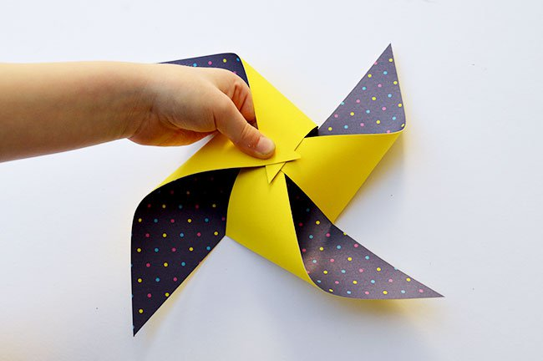

- Finally put the pin through the pencil eraser.

Note – Pin should not stick out from the other side of eraser for safety.

Run and have fun spinning the wheel !!!!
